# Empire Vale Public School logo

**Thursday**

**3 February 2022**

**Week 1 & 2**

[**www.empirevale-p.schools.nsw.edu.au**](http://www.empirevale-p.schools.nsw.edu.au)

**A big *welcome back* everyone! Hope you all had a safe & happy holiday! Students & staff are very pleased to be welcoming our 2022 Kindergarten students to Empire Vale PS!**

**School Captains Term 1**

Congratulations to our new School Captains for Term 1, 2022. We know Keirah, Koda & John Carlo will do their best in being good role models and leading our students well this term.

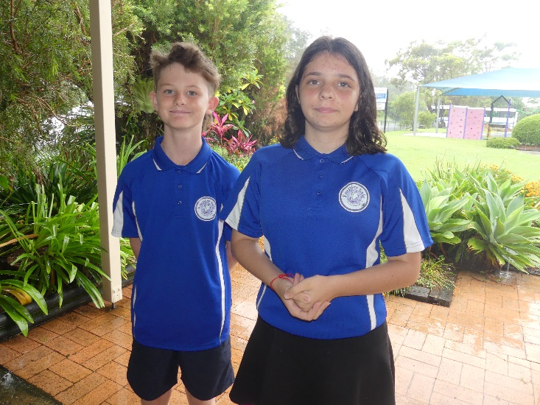

|  |  |
| --- | --- |
| **WEEK 1 & 2** | |
| **Electronic Attachments**   * Permission note for the swimming carnival * Information regarding a community transmission * Current COVID information for schools | **Physical Attachments**   * Permission note for the swimming carnival * PSSA Trials (yrs 5/6) * Year 7 * COVID RATs and information distributed last Friday 28/1 and Monday 31/1 * Additional RATs will be available for collection next Thursday & Friday |

***RESPONSES DUE***

**Swimming Carnival** (8yrs and older)

**Due: Thur 10 February**

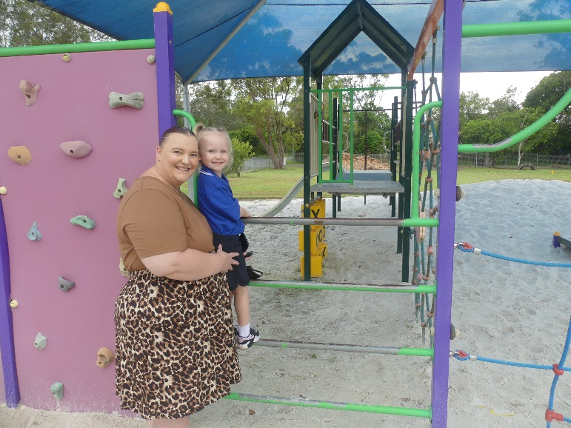

**2022 Staffing**

Classes and staffing have been confirmed for 2022…..

K-2 – Ms Sexton / Ms Smith (returning later in the year)

3-6 – Ms Avery / Mr Sugden

Support Teacher – Mrs Rantissi

Chaplain/ Student Support – Darren Barnwell

Student Support –Trish Antoniacomi

Admin/Office – Lyn Welstead / Cheryl Morton

Library Admin – Tom Albans-Irwin

Maintenance – Billy Goodwin / Mark Thomson

TAFE Volunteers – Aranka Zsidi / Sonya Nourse

**2022 Small Schools’ Swimming Carnival**

The 2022 Small Schools Swimming Carnival for yrs 2-6 is scheduled for ***Thursday* 10 February.** Students 8 years & older who can swim 50 meters will be involved in the carnival. Infants’ children (+ older children unable to swim 50m comfortably) will remain at school for normal classes.

**Time**: Arrival 9:45 (10am start) Finish approx. 1:30pm/2pm.

**Venue**: Ballina Pool

**Transport:** Students will require private transport on the day which will need to be organised by each individual family.

**Pool entry**: The cost will be $5.50 per student and parent/spectator. Payment to be made directly to the pool on the day.

**Wet weather arrangements**: The carnival will go ahead in the rain but will be postponed if severe storms are forecast. In the event of postponement, it will be broadcast on 2LM between 7.30 & 8.30am.

*2021 SSPSSA Carnival*

**Allergy Awareness**

This year in our school there is a student who is severely allergic to peanuts. This could result in the student experiencing anaphylaxis which is a sudden, severe allergic reaction that requires immediate medical treatment and is potentially fatal.

We are seeking the support and co-operation of all families to minimise the risk of this student coming into contact with specific foods. Therefore we request for you to follow these simple steps:

* A picture containing logo

  Description automatically generatedPlease don’t give your children foods containing peanuts to bring to school
  + Peanuts
  + Peanut butter
  + M&Ms
  + Muesli bars containing peanuts
  + Foods cooked in peanut oil
* Be aware of foods that may contain peanuts
* Remind your child about not sharing of food at school
* Remind your child about the importance of washing their hands before and after eating

Thank you for recognising the need for ongoing vigilance to minimise the potential life threatening risk to one of our students.

If you have any queries in relation to this matter please contact Ms Avery or your child’s teacher.

**Welcome to our new Kinders!**

A big welcome to new kinder students; Billy & Ivy who have joined our school this year. In addition we have Billy & Tobin returning to us from QLD as well as Isaac (yr 2) and Rubi (yr 5) who have recently moved to the area. 😊

Ivy is settling in beautifully. We can’t wait for Billy to arrive and join the fun!

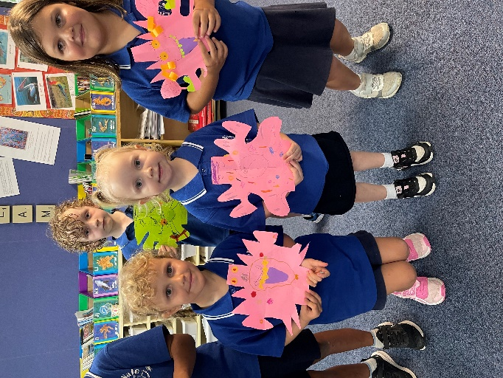

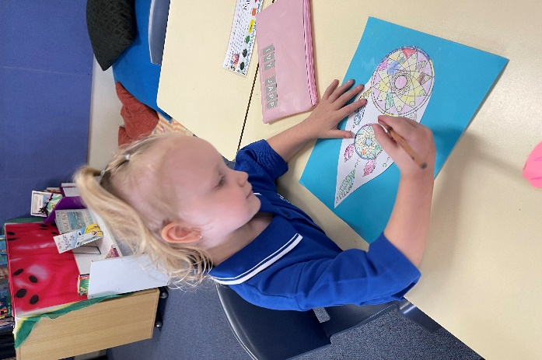

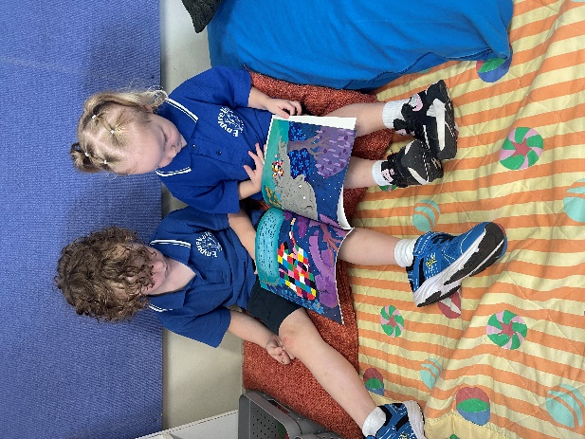

**Allergy Awareness**

Just a reminder that we have a student who is severely allergic to peanuts. This could result in the student experiencing anaphylaxis which is a sudden, severe allergic reaction that requires immediate medical treatment and is potentially fatal.

We are seeking the support and co-operation of all families to minimise the risk of this student coming into contact with specific foods. Therefore we request for you to follow these simple steps:

* Please don’t give your children foods containing peanuts to bring to school
  + Peanuts
  + Peanut butter
  + M&Ms
  + Muesli bars containing peanuts
  + Foods cooked in peanut oil
* Be aware of foods that may contain peanuts
* Remind your child about not sharing of food at school
* Remind your child about the importance of washing their hands before and after eating

Thank you for recognising the need for ongoing vigilance to minimise the potential life threatening risk to one of our students.

If you have any queries in relation to this matter please contact Ms Avery or your child’s teacher.

**COVID Frequently Asked Questions**

**RATs** – More will be available for collection from Monday 7 Feb. We recommend 2 per week with tests conducted prior to school on Monday and Wednesday. That should be enough supply per child to see us through until the middle/end of week 8 (this week is the official school week 2 – even though it’s the kids first week back)

**RAT Results**

* **Negative** Results - We do not need to know about negative results
* **Positive** Results – Please register a positive result with Service NSW (through the App) as well as notifying the school. Your child will then neen to isolate for 7 days as per NSW Health guidelines. At the end of the 7 days they may return to school IF they are symptom free and have a negative RAT.
* **Close Contact** - In the event of a family member testing positive, your child needs to (preferably) isolate away from the positive family member and remain at home as a ‘close contact’ for the 7 day period. Please complete a RAT prior to returning to school to ensure a negative result and that your child is symptom free.

**Parents / visitors onsite -** Currently, visitors on school sites continues to be restricted to essential visitors only. Please contact the school if you need a meeting with teachers and we can put COVID safe practices in place to accommodate this.

**Masks** – Masks are NOT required for primary aged students but are available in each classroom for those students who would like to wear them. Adults (including staff) are required to wear them indoors. These will be removed briefly if children require unimpeded access to the teachers voice and facial expression to aid learning.

**Sanitiser** – Sanitiser is also are NOT required for primary aged students but is available in each classroom for those students who would like to use it.

**Hand-washing** – This is vital for all students, staff and visitors. Sensitive hand soap is available for students with skin sensitivity.

**QR Code sign in** – Visitors to NSW Department of Education schools are required to sign in to the school. The QR code that was originally designed for COVID use now doubles as the visitor sign-on book. This means that regardless of community QR guidelines, school QR codes will continue to be used.

**Learning during 7 day isolation periods –** Staff are currently working on a solution to this and we will be distributing work packs and guidelines for use in the coming week.

**Other messages that may be circulating**

* RATs will not be conducted at school by staff and certainly not without parental consent
* Vaccination will not be conducted at school by staff and certainly not without parental consent

*Thanks for your patience and understanding.*

**Communication**

**Phone**

* Our answering machine is always on. If teachers are on class and our admin staff are absent, please leave a message.

**Newsletter**

* This year the aim will be to distributed our newsletter electronically each fortnight on a Thursday.
* Our Newsletter will mostly contain information you will need (including permission notes). We will do our best to also provide a printed copy of the permission notes but will not be printing the newsletters (except this one ☺).

**Face Book page**

* Our FB page is primarily used as an overview of activities the students are involved in. Please ‘like’ our page to receive alerts. The FB page will have photos and school events. Please don’t ‘friend’ us as we have a generic profile page for Em Vale. This is not an active profile or page, it is simply the host profile for our Empire Vale page!

**Face Book parent page**

* This FB page is restricted to parents and will be used for last minute reminders (e.g. RAT reminders 😊)

**Website**

* Newsletters uploaded fortnightly and photos galleries uploaded periodically
* Parent Online Payments are made through the link on our webpage.

**Email**

* The newsletter will be emailed each fortnight.
* You can email student absence responses to the school’s email address.
* Most correspondence between you and the school can be done through our school’s email address.
* Please don’t use this for urgent bus messages as the email is often checked after school hours.

**Text Message**

* Generally we will only use this if it is a more personal message for your family only (i.e. confirming a teacher meeting).
* Text messages will also be used from time to time to deliver time-sensitive messages (e.g. an adjusted return time from an excursion)
* Please don’t use this for urgent bus messages as we have poor mobile reception at school and often won’t receive your message until we have left the school.

What we need from you….

1. **Check** your child’s bag each fortnight for the newsletter – or check the website or your email.
2. **Read** the newsletter…..
3. ‘**Like’** our FaceBook page
4. Ask to **join** our Parent FB page
5. Provide us with your **current email** and **mobile phone number**
6. **Bookmark** the school Website

Thank you for your assistance.

**Sending Monies in to School**

From time to time money needs to be sent in to school for excursions and other activities.

How to pay;

* **Cash** (placed in an envelope with name, amount and purpose written on the envelope)
* **Chq** (placed in envelope with name etc……..)
* **Parent Online Payment** (send in a hand written note stating what you have paid for and the receipt number issued)

The **Parent Online Payment (POP)** payment page is accessed from the front page of the school’s website by selecting **$ Make a payment**

When you access $ Make a payment you must enter:

* the student’s name, and class and reference number

OR

* the student’s name, and date of birth.

These details are entered each time you make a payment as student information is not held within the payment system.

**j0199228j0199228MOBILE LIBRARY**

Wednesday 9 Feb

Up & Coming Events

**January**

**Friday 28 / Monday 31**

RAT distribution for weeks 2 & 3

*(FYI officially the first week of school for the students is actually ‘week 2’)*

**February**

**Tuesday 1**

First Day of school 2020 for year 1-6

**Wednesday 2**

First Day of school 2021 for Kindergarten

**Thursday 3**

‘Best Start’ assessments for Kindergarten

**Monday 7 - Friday 11**

RAT distribution for weeks 4 - 8

**Thursday 10**

Small Schools PSSA Swimming Carnival

Venue: Ballina Pool

**Wednesday 16**

Headlands District PSSA Swimming Carnival

Venue: Ballina Pool

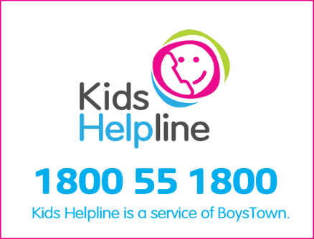

**Mobile Library Visits**

*Every second Wednesday the students from Empire Vale get to attend the Richmond Tweed Mobile Library. It conveniently has its scheduled stop at the front of our school.*

*Garry & Michael, the Librarians, show the students many interesting books in the library and speaks to the students about whether they are fiction or non-fiction.*

*Students in the junior class are allowed to borrow two books to take back to the classroom and share with others until the library returns in a fortnight.*

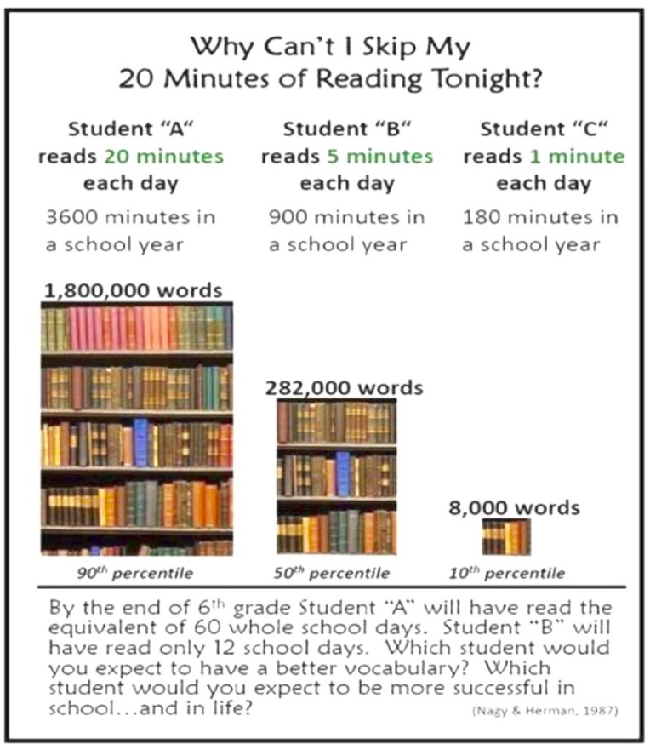**Mobile Library procedures:** Students can borrow and return from the mobile library and can also use the same card to borrow and return from other local Richmond-Tweed Libraries. (Alstonville, Ballina etc.)

Parents and community can also utilise the mobile library to return books they’ve borrowed from town to borrow or reserve books. The mobile library is parked outside the school each second Wednesday from 9:30-10:30, including holidays.

**3-6 Class**: Senior students are responsible their own library card and take their books home until the next visit. Books may, alternatively, be returned to other branch libraries including Ballina, Alstonville etc.

**K-2 Class**: Student library cards are held by the class teacher for safe keeping & are distributed to students on Mobile Library day. (Please note that you may access your child’s card at any time. Please send a note to the front office if you would like your child’s library card NOT to be kept in our care – i.e. you need access to it at other times to borrow from the town libraries).

Junior class students are encouraged to leave their books with the class teacher for the duration of the loan, where they will be accessed during free reading time.

Students will receive a Library Membership form on Thursday 10 February. If you wish your child to access these services please fill in and return the form to the office.

*Please Note: By signing an application for your child to receive a mobile library card you are acknowledging that you understand that all returns, outstanding loans &/or fees are the responsibility of the parent.*

**P&C News**

**P&C Meeting** – AGM to be confirmed

Payments made to the P&C - Please note that payments made to the P&C cannot be made via Parent Online Payments (POP) through the school. Payments to the P&C may be made by;

* Cash
* Cheque
* Direct Deposit (BSB 032 591 / Account 378203)

**Unforms** – available through the canteen each Thursday. Please send in your order form with payment and we will fill the orders each week.

**Canteen** – Start date delayed due to restricted volunteers on site

**Canteen Procedures**

* **ALL** items ordered from the canteen are to be written on a paper bag with your child’s name. Please place the correct money in the bag.
* A separate order is required for recess & lunch items.
* CORRECT money please. We don’t always have change available to send home.
* Orders to be placed in notes box Thursday morning, (located in front of office).

**School Uniform Reminder**

We are very proud of our school uniform and congratulate the many students who consistently wear the correct school uniform and who look so smart.

Parents are asked to help develop school pride and unity by purchasing the school uniform. Please ensure your children attend school and school functions in full school uniform at all times.

**Boys Summer:**

* Navy blue shorts
* Blue polo shirt printed with school emblem on pocket.
* Covered footwear i.e. joggers, school shoes
* Blue school hat available through the P&C

**Girls Summer:**

* Blue & white checked culottes or blue shorts.
* Blue polo shirt printed with school emblem on pocket.
* Covered footwear i.e. joggers, school shoes
* Blue school hat available through the P&C

**Girls & Boys Winter:**

* Blue school jacket or blue jumper

**Girls & Boys Sport:**

* Black skirt, shorts or bike pants**.**
* Blue polo shirts with large emblem on front.
* Covered footwear i.e. joggers

Community News

**Music in Schools**

**(Northern Rivers Conservatorium)**

**

*Thank-you for supporting Music in Schools in 2020, and I look forward to working with you in 2022.* ***We will be starting Week 3***

*As per our terms and conditions of enrolment, we require all continuing students to complete a re-enrolment form on our website.*

*Re-enrolmenting students please head to our website, and select ‘Music in Schools’ and follow the prompts* [*https://enrol.nrac.edu.au*](https://enrol.nrac.edu.au)

*If you have a child wishing to enrol in the program for the first time in 2022, you will need to fill out a new enrolment form on our website* [*https://enrol.nrcac.edu.au/music-in-schools/new/*](https://enrol.nrcac.edu.au/music-in-schools/new/) *alternatively go to the NRC website at*[*https://nrcac.edu.au/music-in-schools/*](https://nrcac.edu.au/music-in-schools/)*and select 'click to enrol' on the right hand side.*

*Please see our website for terms and conditions of enrolment.*

*If you haven't followed us on Facebook yet – please do!*

[*https://www.facebook.comnorthernrivers.conservatorium*](https://www.facebook.comnorthernrivers.conservatorium)

Anita Bellman

***Music Programs Coordinator   
Northern Rivers Conservatorium   
(ph) 02 6621 2266***

[*https://nrcac.edu.au/music-in-schools/*](https://nrcac.edu.au/music-in-schools/)

*The conservatorium also has Bursery Applications for anyone who would like their child to participate and qualifies for financial assistance.*

<https://www.service.nsw.gov.au/transaction/apply-creative-kids-voucher>

**Creative Kids Voucher 2022**

The Creative Kids provider guidelines were updated on 1 January 2022 to refocus the Creative Kids program on encouraging children and young people to participate in interactive, real-time creative programs.

As part of these updates, effective 1 January 2022, the following program delivery formats will become ineligible:

* art/craft kit programs (any programs that involve the participant receiving creative supplies or materials) without live lesson delivery
* online programs that are not delivered in real-time (live), for example, pre-recorded video lessons/tutorials.

**Active Kids Voucher 2022**

The NSW Government is helping kids get active with the Active Kids program.

The Active Kids program provides two $100 vouchers for parents, guardians and carers of school-enrolled children to use towards sport and active recreation costs each year.

Voucher 1 is valid January to December and Voucher 2 is valid July to December.

For more information please see the information on the Service NSW webpage (search Creative Kids & Active Kids)

The Australian Electoral Commission (AEC) conducts federal elections, including by-elections, plebiscites and referendums. Although the date for the next federal election is yet to be announced, the AEC is preparing well in advance to ensure it has a professional temporary election workforce to deliver Australia’s largest peacetime event.

In NSW/ACT the AEC employs approximately 40,000 staff to perform a wide range of paid temporary election roles. These roles may be before, on and after election day, and range from supervisory to administrative, logistics and team member roles. Polling officials play an important role in delivering a successful election, conducting polling not only on election day but through early voting centres, mobile polling, via post and overseas. For the next federal election COVID-Safe measures will be in place at all polling places and workplaces to protect workers and voters.

The AEC maintains an ongoing national register of people who are interested in working at federal elections. The Grafton Office of the AEC (incorporating the Federal Division of Page) is currently reviewing the register and identifying suitably skilled staff to work for at the next election.

We have typically found many people possess many of the skills (e.g. project management, supervisory, attention to detail etc.) required of election day staff. As your school is located within the Federal Division of Page we would like to encourage members of your staff to consider registering their interest to work at the next federal election. As such, we hope that you can distribute this email to members of your staff for their information. Please note that no election experience is required as full training is provided.

Working at elections is a great opportunity to meet new people, make new friends, expand your skillset, contribute to your community, and gain a unique work experience while earning extra money.

Further information on working at federal elections is available at aec.gov.au.

**Kerin Hallam | Divisional Office Manager**

There is a lot going on at the Richmond Tweed Regional Library!

Follow the link to see whats happening

<https://view.flodesk.com/emails/61aed3a654de38a190f68780>